Module 4: Hardware and Software Divisions of the Cities
Exercise 2: The socioeconomic divisions of our city

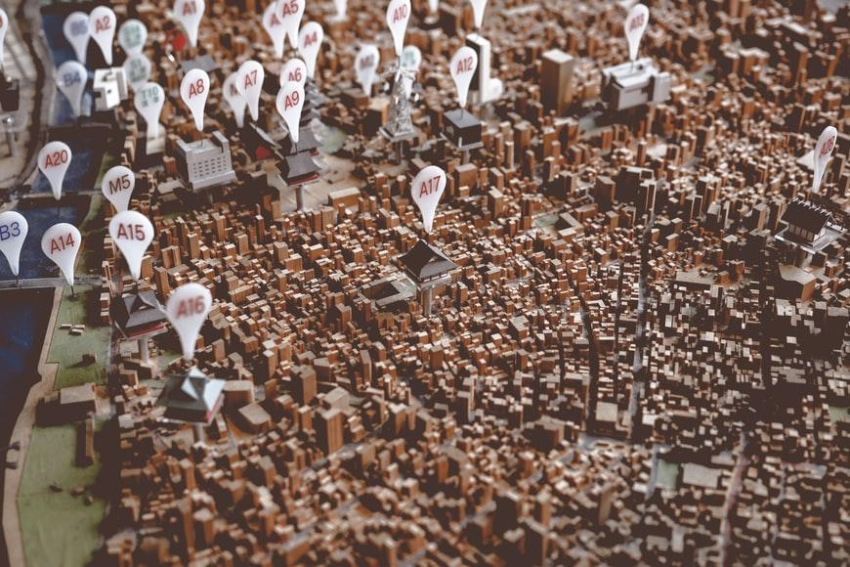
Source: https://unsplash.com/photos/dWwZBcjw3GE by Thor Alvis
Steps:
- Use GmapGIS: https://www.gmapgis.com/or Scribblemaps: https://www.scribblemaps.com/to find the map of your own city/town and draw on the map using the Draw Tool [Draw line] the socioeconomic divisions that may exist in your city e.g., underdeveloped areas/neighbourhoods, rich and developed areas, middle class neighbourhoods etc., always according to your experience and opinion. You can draw a circle or a line of the division that is created in your city and use the “Label” tool to write down what kind of area is that.
- Think about: are these socioeconomic divisions also related with cultural/religious divisions regarding the areas in your city?
- If yes, please write down each relevant choice and provide also a small comment about the area you chose. [e.g., this underdeveloped area is mainly inhabited by newly arrived Muslim immigrants; or e.g., this is middle-class area is inhabited mainly protestants working in the military, or e.g., this is a working-class neighbourhood with many migrants where political projects and actions take place etc.]

Area | Type of related Divisions | Comment
 | Cultural/Religious division

- Now focus on the area/neighbourhood or community you are living in and answer the following question: Was this area always in that situation [developed/underdeveloped-rich/middle class/poor etc.] as it is today or was it different in the past? Answer shortly in 3-6 sentences. Participants can also check on the web to gather information for this question.
[e.g. This area used to be a middle-class commercial centre at the beginning of the previous century but it was destroyed during WWII, its inhabitants left and Jewish refugees of war or foreign workers from Italy came to stay and work etc.]
- Briefly present your answers and discuss in the seminar room, with your fellow participants your map and your answers. (Optional)

Food for thought:
- Did you find the exercise interesting?
- How many physical divisions exist in your city?
- Is there a connection between socioeconomic divisions and ethnic/religious/cultural characteristics of these parts of the city?
- Is your area in a better condition today than it was in the past?
- Were your maps and answers similar to your fellow participants, did you find common ground in your discussion?

