Module 1: Civic Pride
Exercise 5. Marketplace
Steps:
- Prepare your material for the observation (notebook + pen, audio recorder device, smartphone, sketchbook…)
- Go to your marketplace and sit on a bench where you can properly observe people.
- Take a look around and observe people passing by for a couple of minutes
- Then start recording your observations through the material you have selected. You can use the following table including some useful questions to analyse people around you.

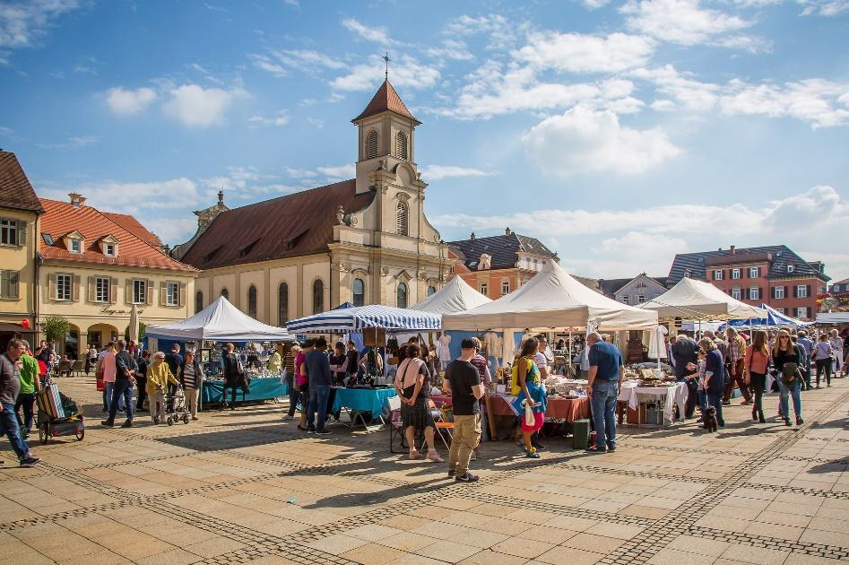
Source: https://pixabay.com/fr/photos/ludwigsburg-allemagne-march%c3%a9-2779468/ by maxmann

- Observation Table

QUESTIONS | OBSERVATIONS
At first sight, which type of people are predominant in this place?

Is this place more/equally frequented by men/women? Why?

What is the dominant age group? What is the reason for this?

Which feeling prevails among these people? (Happiness, sadness, boredom, …)
Is this place more frequented by residents/tourists?

Is it a living place? Describe it

Is this place attractive? Does she have something particular/unique? (architecture, historical background, events,...)

Do you think some arrangements should be carried out to improve this place?

- After a few minutes of observation, describe two people who stand out from the crowd? Why would you choose them?
- Synthetize your observations and make a short description of your marketplace (or relevant place).
This could be carried out as text, e-portfolio, presentation for social media, comics, etc…
- The analysis should be shared online in social media for feedback.

